USER MANUAL

INTERACTIVE TABLE

INTBOARD STYLE

Contents

1. INFORMATION ABOUT THE SUPPLIER

2. GENERAL INSTRUCTIONS

3. SAFETY REQUIREMENTS

4. SCOPE OF DELIVERY

5. APPEARANCE AND DESCRIPTION

6. PREPARATION FOR WORK

7. SETTING UP INTBOARD JOY

8. MAINTENANCE

9. RULES OF TRANSPORTATION

10. STORAGE RULES

11. ECOLOGY

12. WARRANTY OBLIGATIONS

13. TECHNICAL CHARACTERISTICS

1. SUPPLIER
Country of origin of the product: China
Manufacturer: 2F Building 8, YiLisheng Industry Park, Fuyong, Baoan District, Shenzhen, 518103, China
Official representative in Poland: CREO SYNERGHY sp. z o. O
Address: ul. Marii Curie-Skłodowskiej 3/27 20-029 Lublin.
E-mail: info@intboard.pl
Company's website: intboard.pl

2. GENERAL INSTRUCTIONS

This Manual is intended for the INTBOARD STYLE Interactive Table (the Interactive Table). All installations and operations related to the Interactive Table must be performed in accordance with this Manual.
2.1 The Interactive Table is designed for educational purposes in preschool and school institutions (primary grades) to improve the learning process. The Interactive Table can also be used for entertainment purposes in shopping malls or special children's rooms.
2.2 The Interactive Table is a device powered by a 230 V 50 Hz network. It is intended for indoor use. The Interactive Table is equipped with a built-in computer running an Android or Windows operating system, built-in speakers, WiFi and Bluetooth. The Interactive Table on Android has pre-installed applications, as well as the Play Market app store, so the user can install the applications necessary for work. The Interactive Table is controlled by touching the screen with a finger or a special marker for capacitive screens. Typing is done with the help of a virtual keyboard that automatically appears on the screen, for example, when entering a password for a WiFi network.
The user can install specialized applications for training and entertainment or any other applications for working with documents, photos, and videos on the Interactive Table. The built-in speakers allow you to broadcast educational or entertainment videos with sound on the table. All installed applications can be uninstalled by the user if necessary.
The Android-based interactive tables are shipped with the operating system, the INTBOARD JOY, and Fully Kiosk Browser applications. Windows-based interactive tables are shipped without the Windows operating system. The Windows operating system is installed separately for an additional fee.
NOTE! The Interactive Table is not intended to be used as a table for eating/drinking or for heavy loads. If the interactive table is used for other than its intended purpose, the manufacturer is not responsible for the consequences, and the Interactive Table is not subject to warranty repair.

NOTE! If the consumer violates the rules set forth in this Manual, the manufacturer is not liable for moral and physical damage and also withdraws from the warranty.

3. SAFETY REQUIREMENTS

Before using the Interactive Table, please read this Manual carefully and keep it for future reference. Misuse of the Interactive Table can result in serious personal injury or property damage.

NOTE! To avoid electric shock, do not attempt to open the interactive table case yourself. In case of malfunctions, please contact the INTBOARD service center.
3.1. Installation and Movement

- Do not move the Interactive Table while the power cable is plugged in;
- Do not allow liquids to get on any part of the Interactive Table, including the screen, screen housing, or power cord;
- Do not place heavy objects on top of the Interactive Table or on its screen;
- Do not install or use the Interactive Table in areas with high humidity;
- Do not install or use the Interactive Table in a dusty environment;
- Protect the screen from prolonged exposure to direct sunlight;
- Do not place the Interactive Table near a source of heat or moisture. The minimum distance from a source of heat or moisture should be at least 3 meters;
- Do not expose the Interactive Table to strong electromagnetic fields;
- Use the Interactive Table only at room temperature and do not expose it to excessively high or low temperatures;
- Unplug the Interactive Table from the power outlet if you do not plan to use it for a long time.

3.2. Power Cable and Power Supply

- Make sure that the mains voltage corresponds to the device labeling and is 230 V ± 10%;
- Use a grounded outlet and make sure it is properly grounded.
NOTE! The grounding of the power outlet in the building must be carried out by a specialist in accordance with the current electrical safety and building regulations of your country, otherwise the manufacturer is not responsible for moral and physical damage and will withdraw from the warranty.
- Do not use the power cable if it is damaged in any way;
- To avoid the risk of electric shock, do not touch the interactive table casing or power cable with wet hands;
- In the event of lightning or thunderstorms, turn off the Interactive Table and unplug the power cord;
-If the Interactive Table is used in a region with unstable power supply voltage, use an external device to stabilize the power supply;
- Do not place the power cord near heat sources;
- Do not place the power cord near sources of moisture;
- Protect the power cord from physical or mechanical damage. Do not bend or stretch the power cable or the power supply cable by physical force. Do not press them down with heavy objects;
- Always unplug the power cord from the wall outlet when cleaning and maintaining;
- Always unplug the power cord from the wall outlet if you do not plan to use the device for an extended period of time.

3.3. Screen

- Do not use sharp objects to write or operate;
- Clean the screen with a dry, soft cloth or special cloth;
- If you need thorough cleaning, please contact the service center;
- Protect the screen from impacts;
- Protect the screen from prolonged exposure to direct sunlight.

3.4. Ventilation

There are cooling holes on the bottom of the Interactive Table.
- Do not cover the ventilation openings as insufficient cooling can cause overheating and failure.

3.5. Temperature

- Do not place the Interactive Table near a heat source. The distance should be at least 3 meters;
- When moving from a room with a low temperature to a room with a high temperature, wait until the table temperature has equalized to prevent moisture condensation (approximately 6 hours);
- Operating temperature range: 0 to +45°C, storage temperature: long-term – 0°C to +50°C, without moisture condensation.
Short-term up to 5 days – from -30°C to +50°C, without moisture condensation.

3.6. Humidity

- Do not place the Interactive Table near a source of moisture, the minimum distance should be at least 3 meters;
- Make sure the Interactive Table is used in a room with a humidity level of no more than 65% at a temperature of 25°C (without condensation), and a storage humidity level of 10% to 80% (without condensation).

NOTE!!! Turn off the Interactive Table immediately if you experience any serious problems, such as:
- Appearance of smoke, a specific odor or noise;
- No sound or image, image distortion;
- In case of serious malfunctions, stop using the Interactive Table, immediately disconnect the power supply, and contact a service center.
- Do not open the cover or repair the Interactive Table yourself.
For inspection or service, please contact your local distributor or the manufacturer.

NOTE!!!

The supplier shall not be liable to the buyer or any other person in case of violation of the rules set forth in the safety instructions.

4. SCOPE OF DELIVERY

Interactive Table – 1 pc;
Power cable – 1 pc;
Wi-Fi antenna – 1 pc.

The scope of delivery may differ from the one indicated. The manufacturer reserves the right to change the scope of delivery without giving notice to the buyer.

5. APPEARANCE
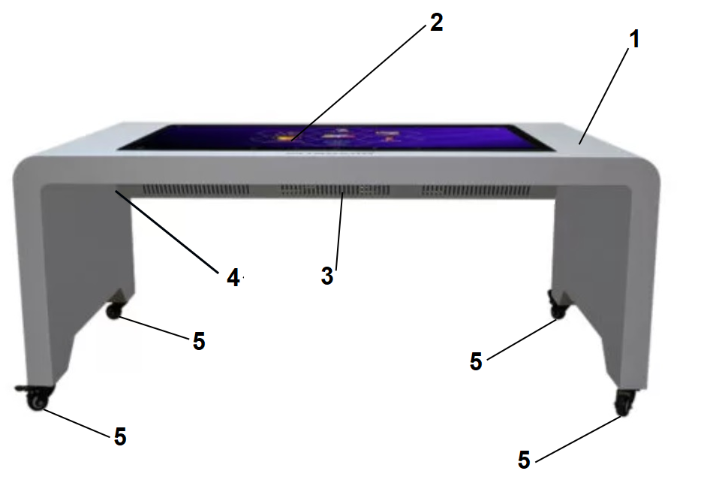
1. Metal case
2. Display
3. Bottom cover with ventilation holes
4. Side panel with connectors
5. Wheels for transportation

5.3 Panel with Connectors
Panel with connectors is as shown below:

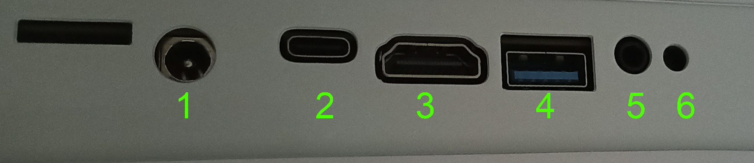

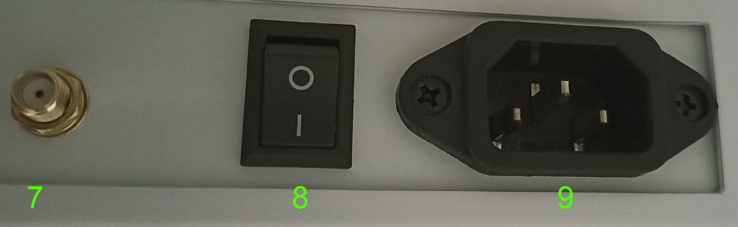

1. Technical Power (used for equipment repair)

2. USB Type-C

3. HDMI IN 2.0

4. USB 3.0

5. Headphone

6. Reboot

7. Wi-Fi Antenna

8. Power on/off

9. Power cable

6. PREPARATION FOR WORK

6.1 Unpack the Interactive Table from its original packaging.

6.2 Check the Interactive Table and its delivery for damage.

6.3 Select a location for installation according to the recommendations in the Security Requirements.

6.4 Install the Wi-Fi antenna.

6.5 After transportation or storage at temperatures below 0°C, keep it at room temperature for at least 6 hours.

6.6 Connect the power cable to the Interactive Table.

6.7 Connect the power cable to the mains. Turn on the power using the switch. Wait for the Android operating system to boot and for the main screen of the INTBOARD JOY app to appear.
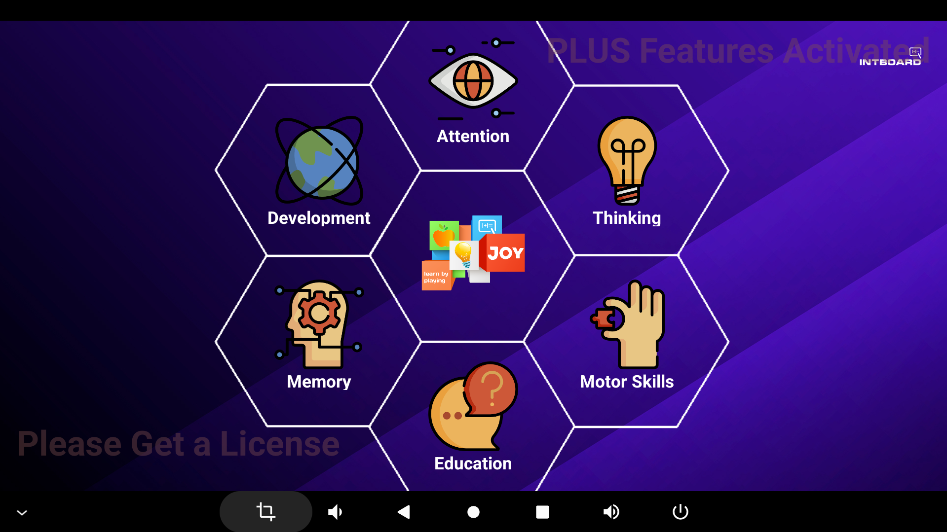
INTBOARD JOY allows you to group previously installed applications on the Interactive Table into the categories you need. The application can work autonomously, but it is recommended to use it together with the INTBOARD Lock program that blocks the operation of other programs.

6.8 To continue working, you need to temporarily turn off INTBOARD Lock, connect to your Wi-Fi network and log in to your PlayStore account. To do this, follow the following steps:
6.8.1 Quickly tap the screen seven times in a row on an empty space. After that, the following window will pop up:

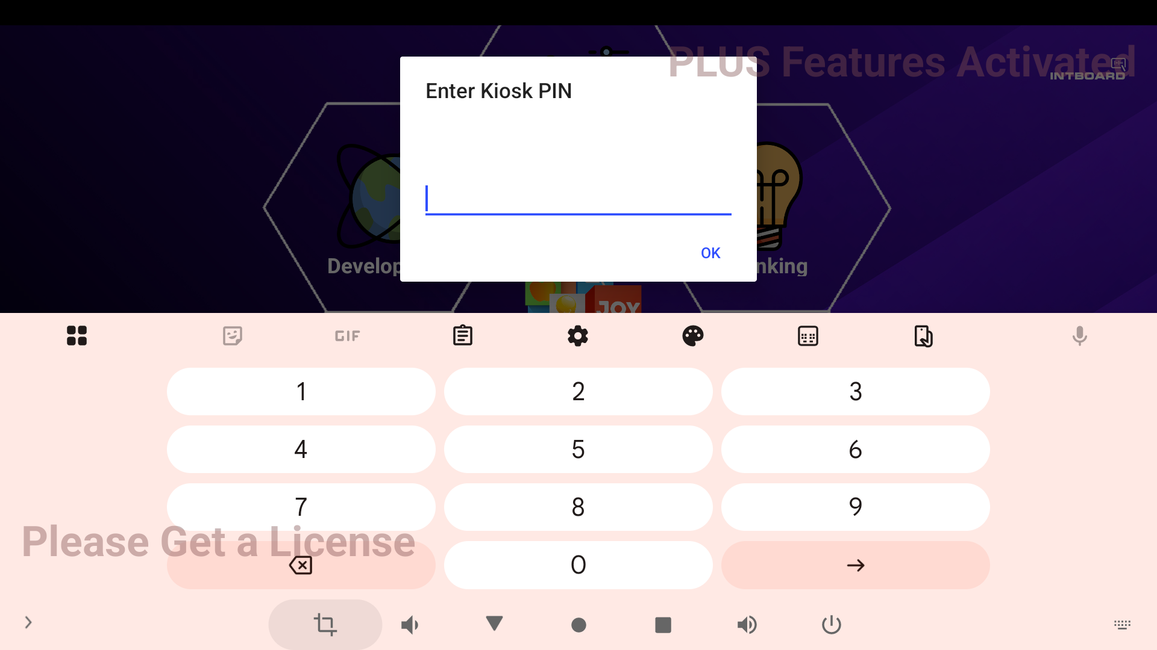

Enter the PIN code (2022 by default) and click OK.

6.8.2 After entering the PIN code, the following window will pop up. Here you need to choose Exit INTBOARD Lock
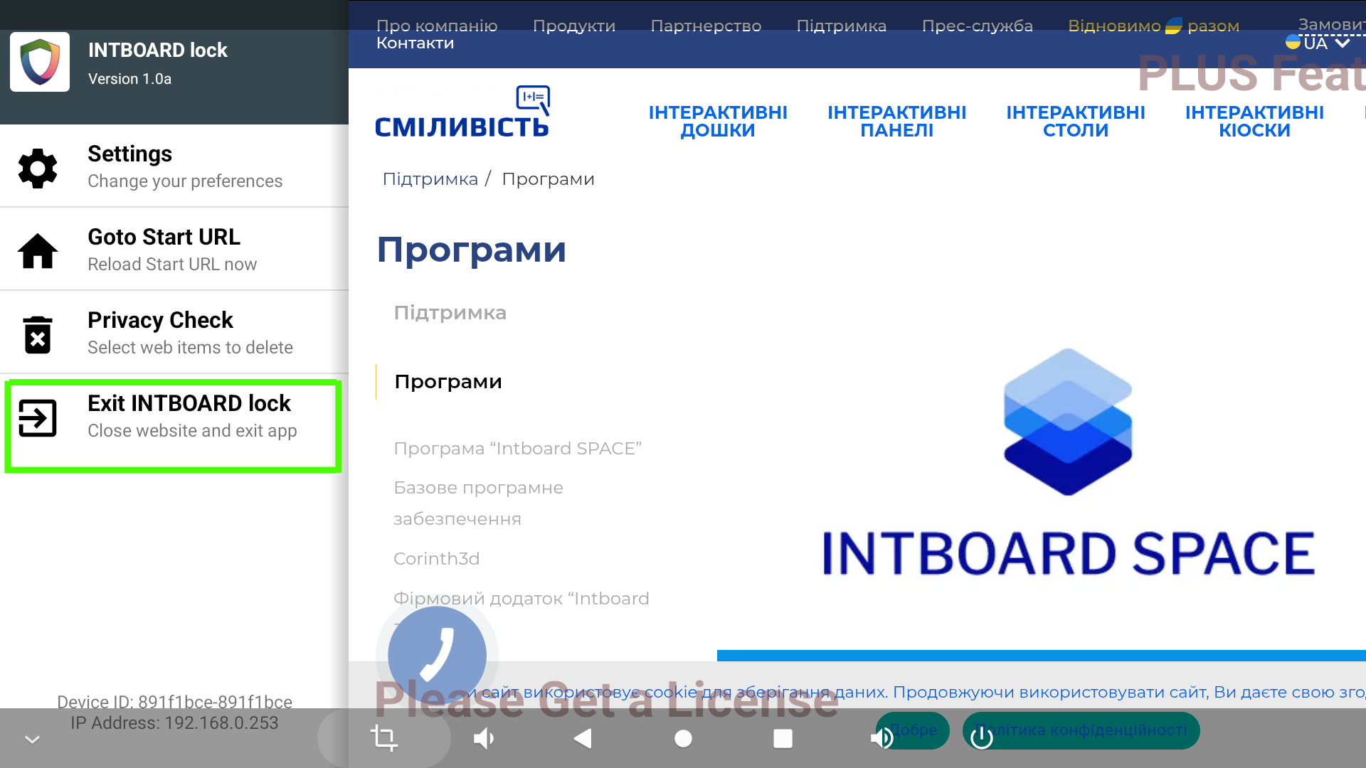

6.8.3 Next, select GO OUT

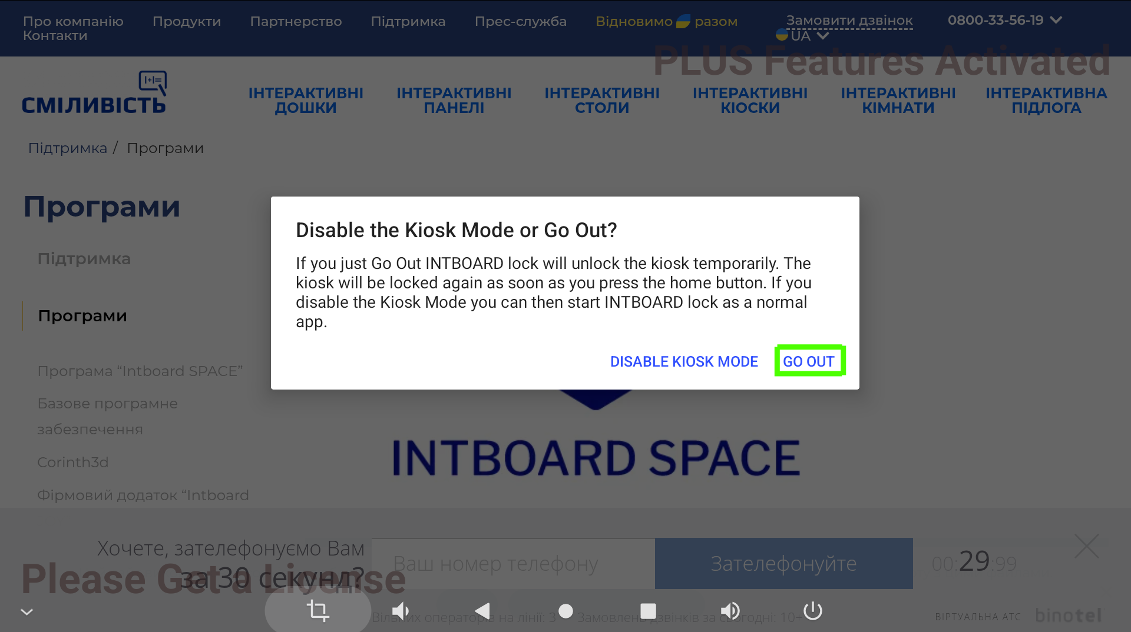

After that, the usual Android desktop will open.

6.9 Connecting to a Wi-Fi network

6.9.1 Go to the Settings

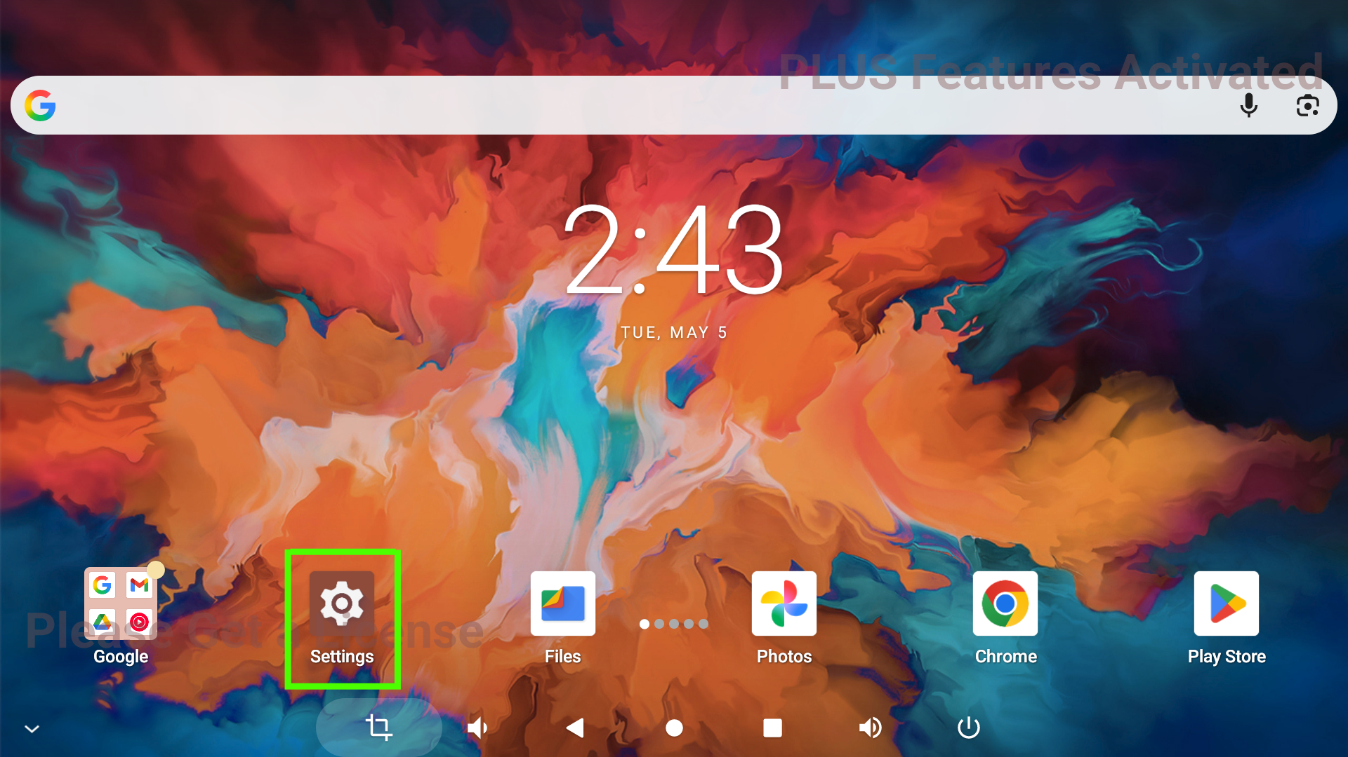

6.9.2 Select Network and Internet and go to Internet
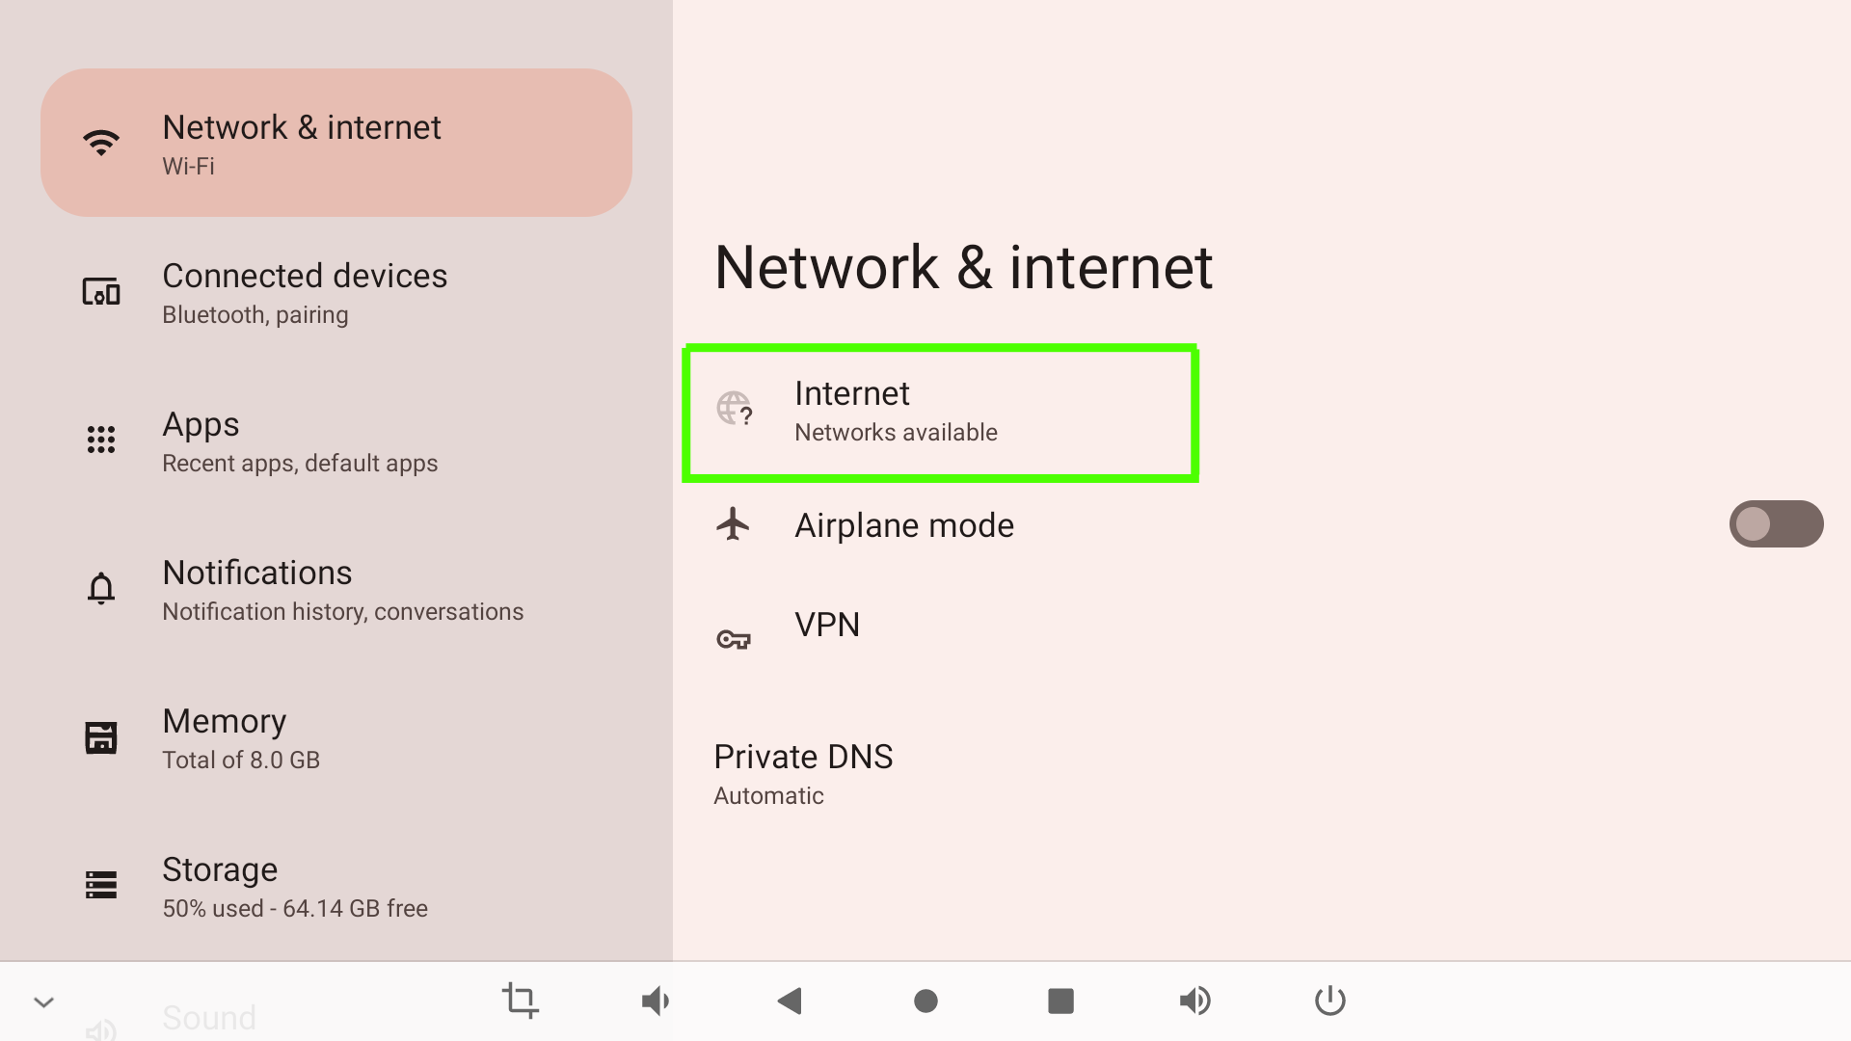

6.9.3 Turn on Wi-Fi by moving the slider to the right. The list of available Wi-Fi networks will open. From the list, select the one you want to connect to and enter the password to connect.
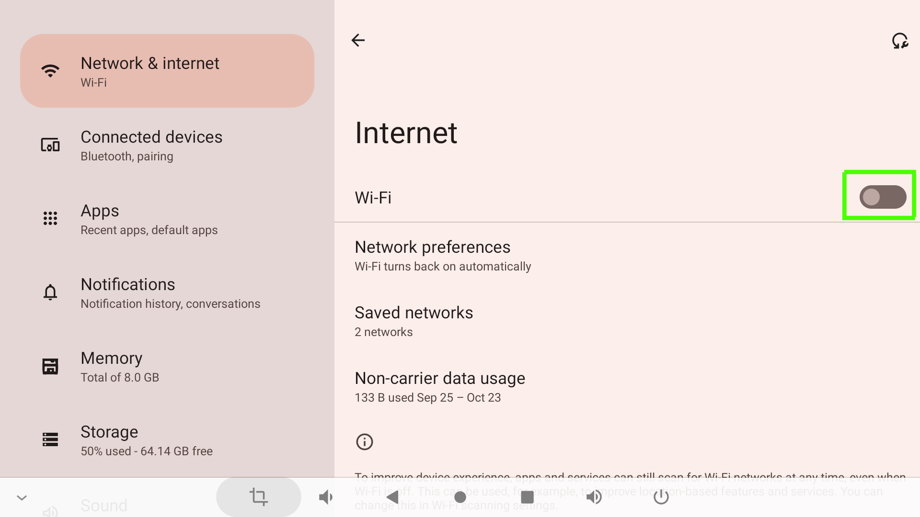

6.10 Exit Settings menu and open PlayStore. Create or log in to your account by entering your email and password.

6.11 After connecting to Wi-Fi and logging in to your PlayStore account, click on the button to view running applications (marked in green) and close all windows. Fully Kiosk Browser will automatically turn on and INTBOARD JOY will open.

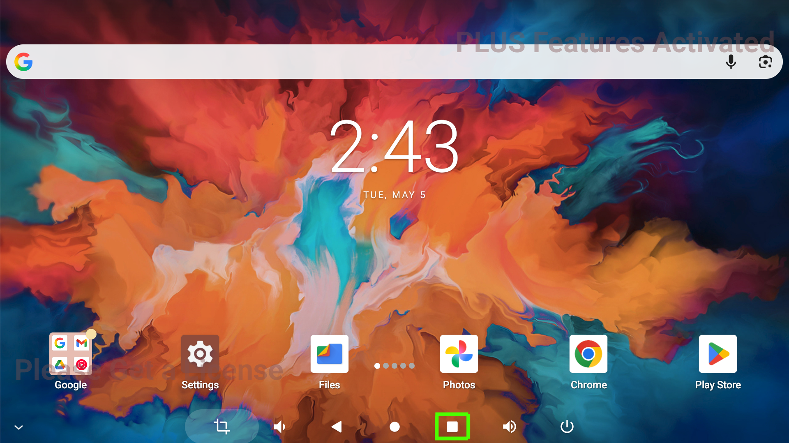

6.12 Other settings

6.12.1 Language selection. Go to Settings
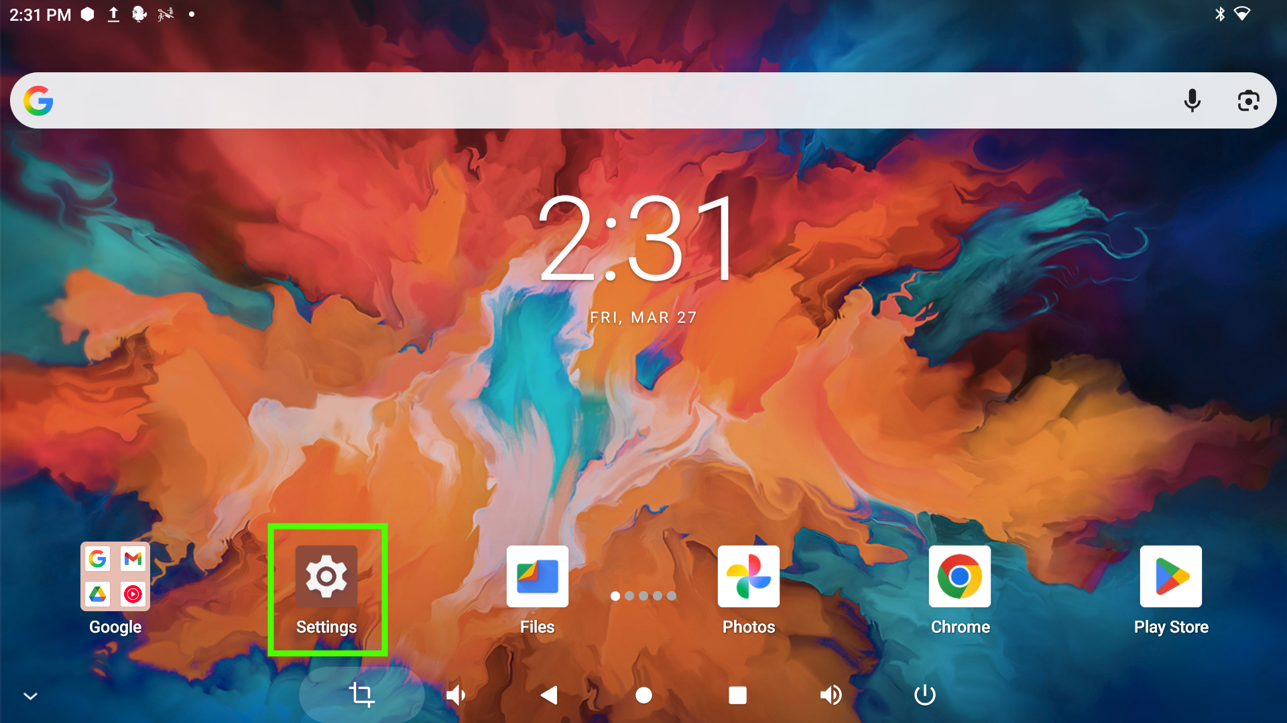

6.12.2 Go to the System and select Language and Input
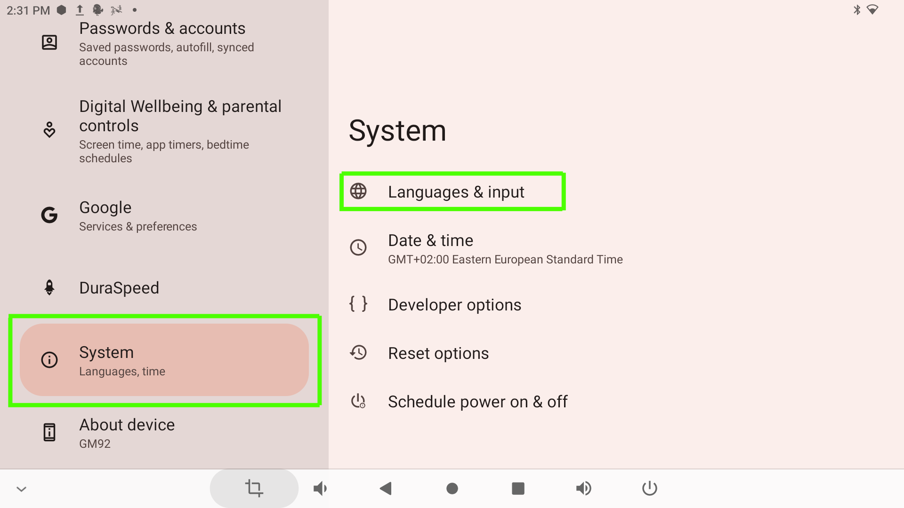

6.12.3 Click Add language and the list of available languages will open.
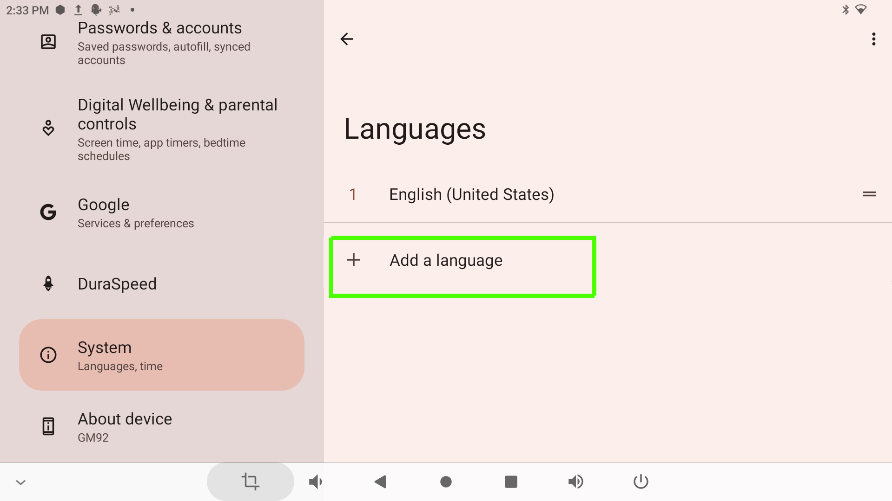

6.12.4 From the list of available languages, select the desired language.
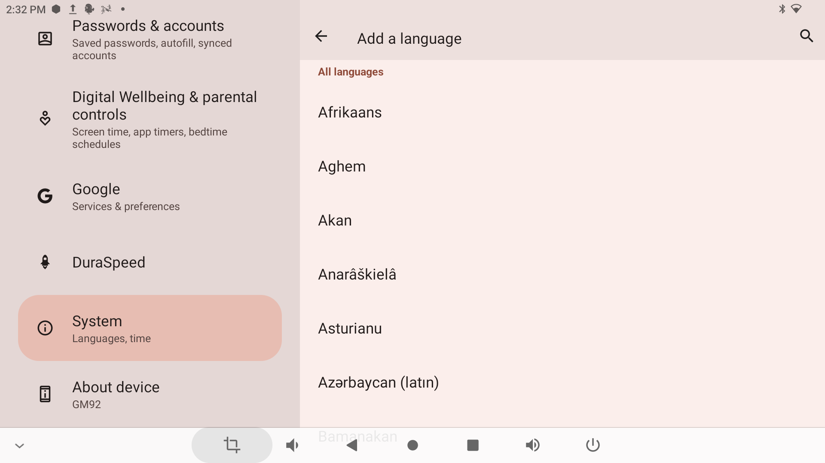

6.12.5 The window with the selected languages will open.
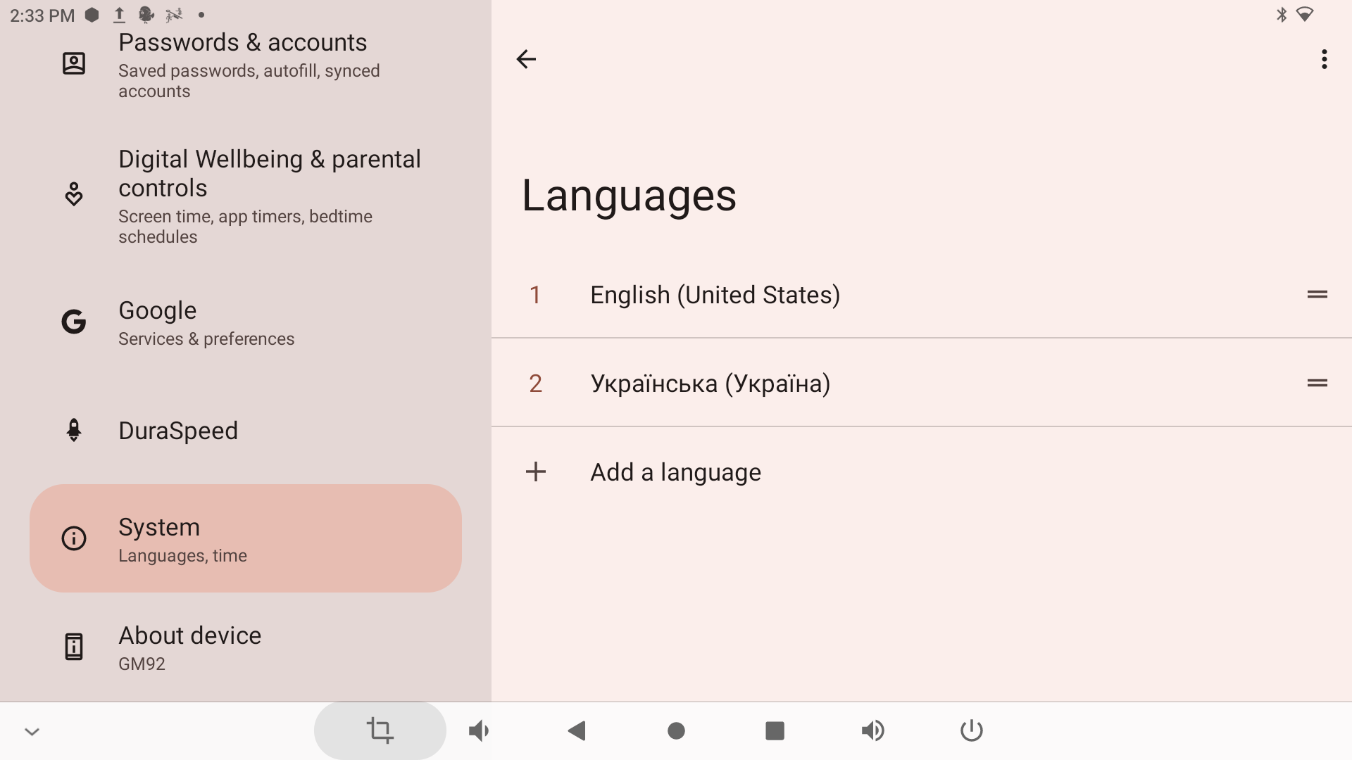

6.12.6 To set the required language, click on the two dashes on the right and drag the selected language to the top of the list.
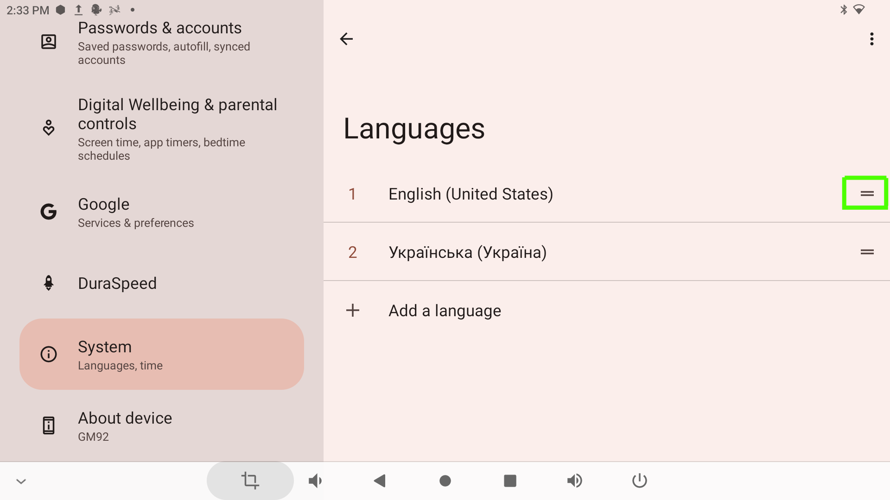

After that, the table menu will automatically switch to the selected language

6.12.7 Setting the date and time. Go to Settings and select System. Click Date and Time
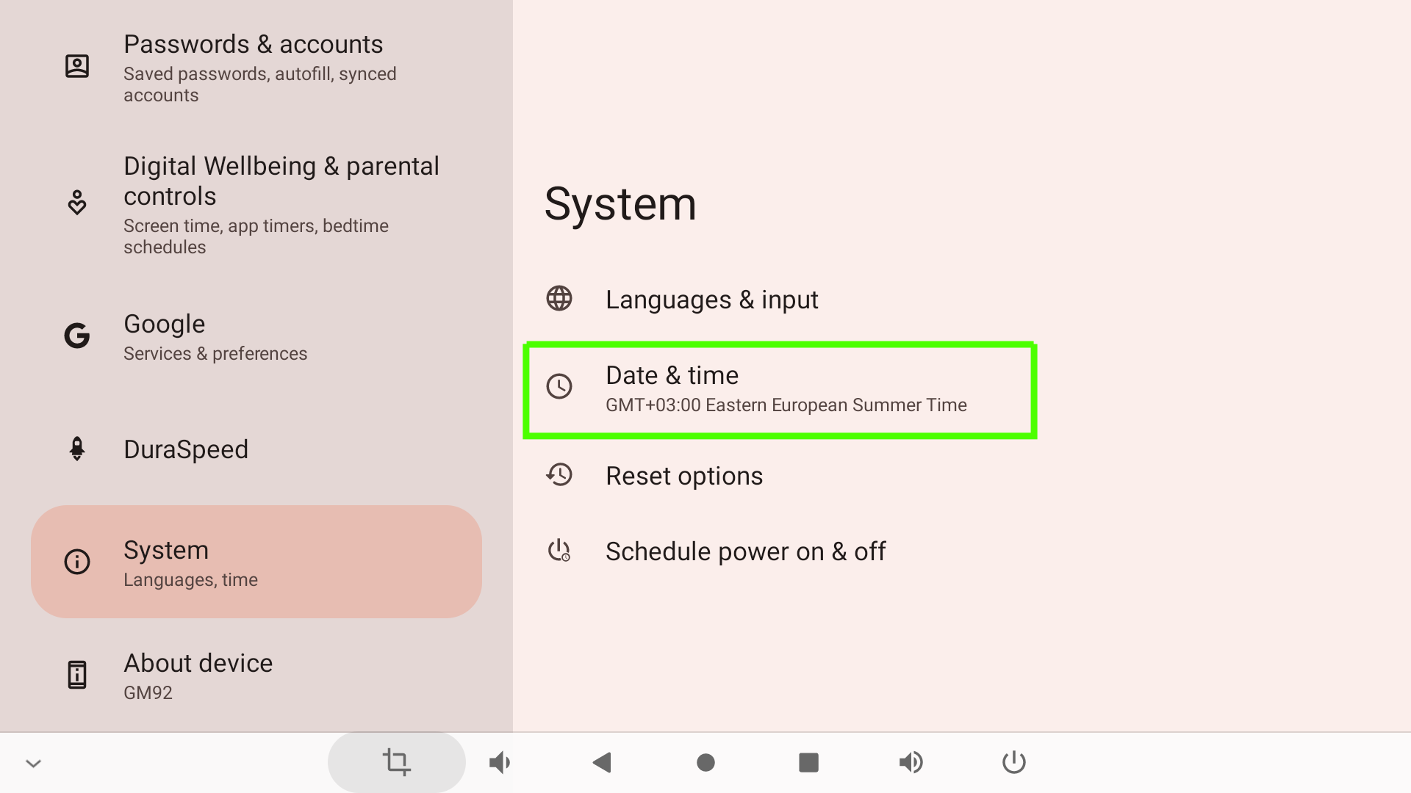

6.12.8 In the menu that opens, click Set Time Automatically and select Use Network-Provided Time.
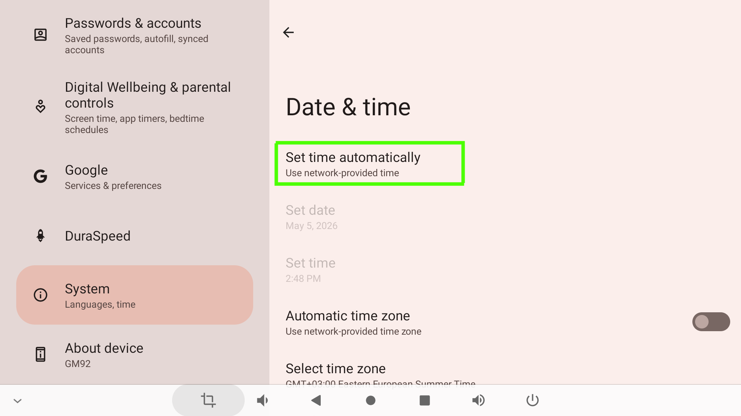

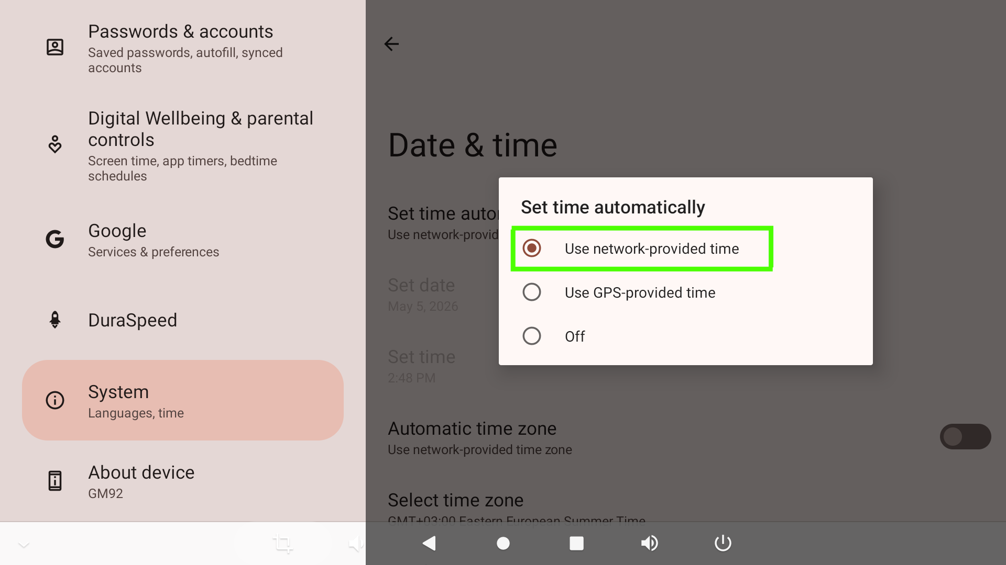

6.12.10 Select Time Zone and set the required region
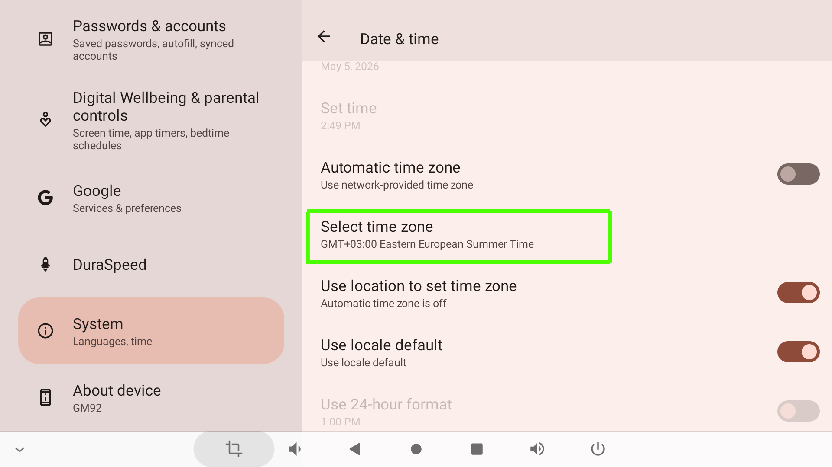

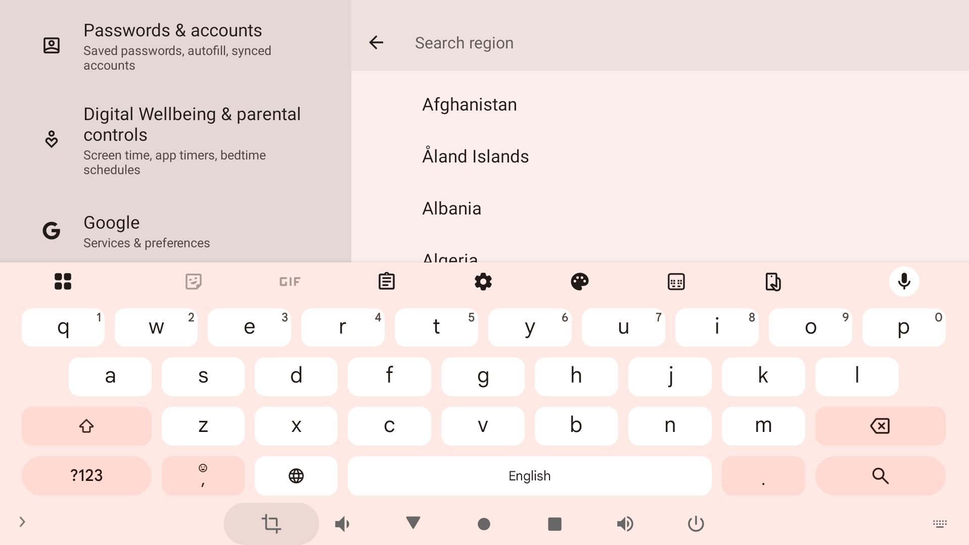

Set the necessary parameters and return.

6.13 Turning Off the Interactive Table on Android. To turn off the Interactive Table, pop up the bottom menu (swipe from the bottom edge to the center) and press the power button 1. After that, a menu will appear in the middle of the screen where you need to press the power button 2 again and confirm 3.

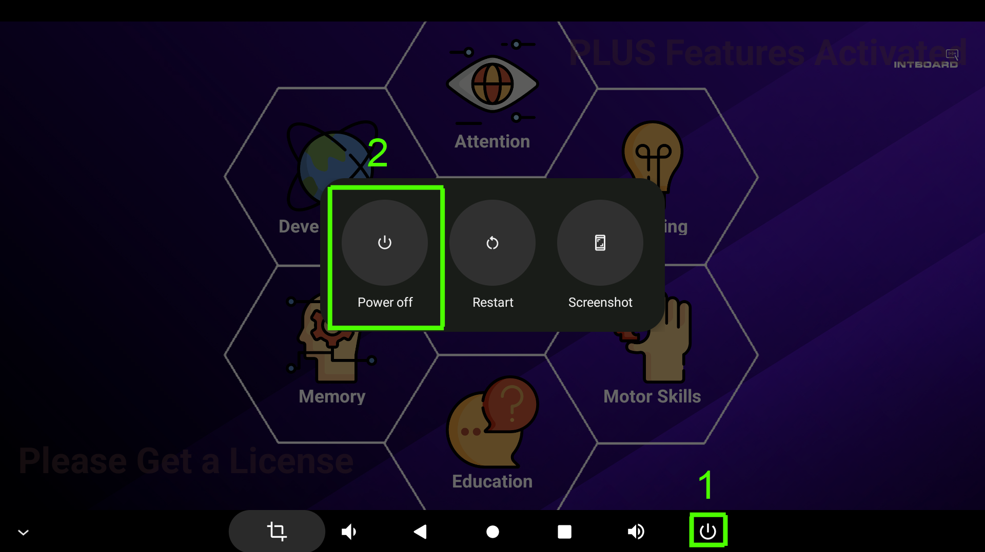

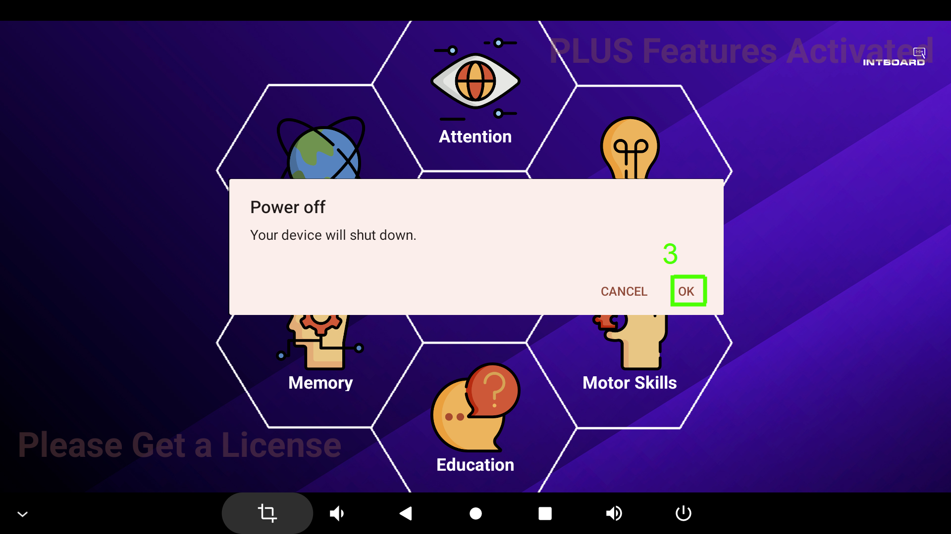

The Interactive Table will be turned off, and you can unplug the power cord from the outlet.

6.14 If you are using the Interactive Table with a built-in computer based on the Windows operating system, you must install the required version of the operating system before using it.

6.14.1 Install and load the Windows operating system. After booting the operating system, you can use the applications preinstalled in the operating system or install other applications at your discretion.

NOTE! The proprietary INTBOARD JOY app and the INTBOARD Lock app are only available on interactive tables with the Android operating system. Windows interactive tables are shipped without the INTBOARD JOY app.

NOTE. If you reset the Interactive Table in the Settings menu, all applications and information will be deleted! To restore the operation of the INTBOARD JOY and INTBOARD Lock applications, please contact the INTBOARD Service Department. Applications are restored for a fee. Sending the Interactive Table to the service center is at the user's expense!

7. SETTING UP INTBOARD JOY

In INTBOARD JOY, you can change the set of applications (.apk extension), category names (no more than 10 characters), background images (.png extension, 512x512 pixels) and desktop wallpapers (.png, .jpg extension, 1920x1080 pixels).

7.1 To access the settings, tap the screen in the area where the INTBOARD logo is located (marked in green) and hold for about 3 seconds.
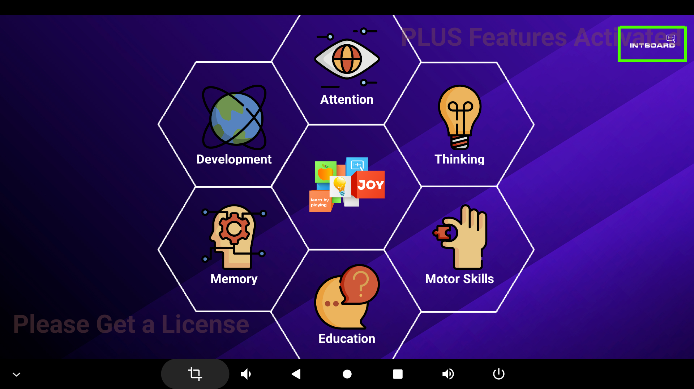

7.2 The password entry window opens. To access the settings interface, enter the password, which is 1111 by default.

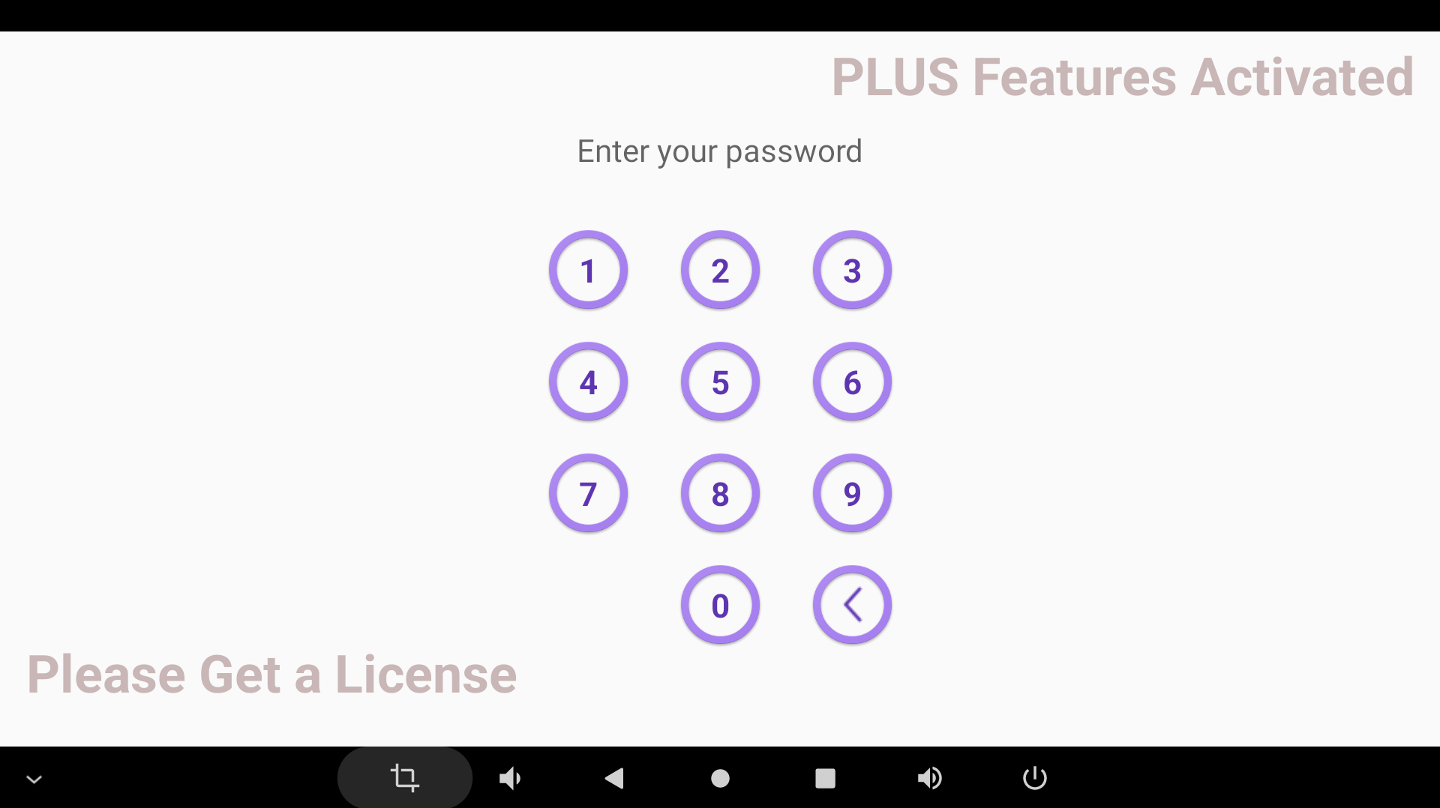
7.3 After entering the password, the application Configuration Interface will open.

Description of the menu items:
1. Change the access password to INTBOARD JOY.
2. View all installed programs.
3. Change the wallpaper of the INTBOARD JOY.
4. Review and customize program sections.
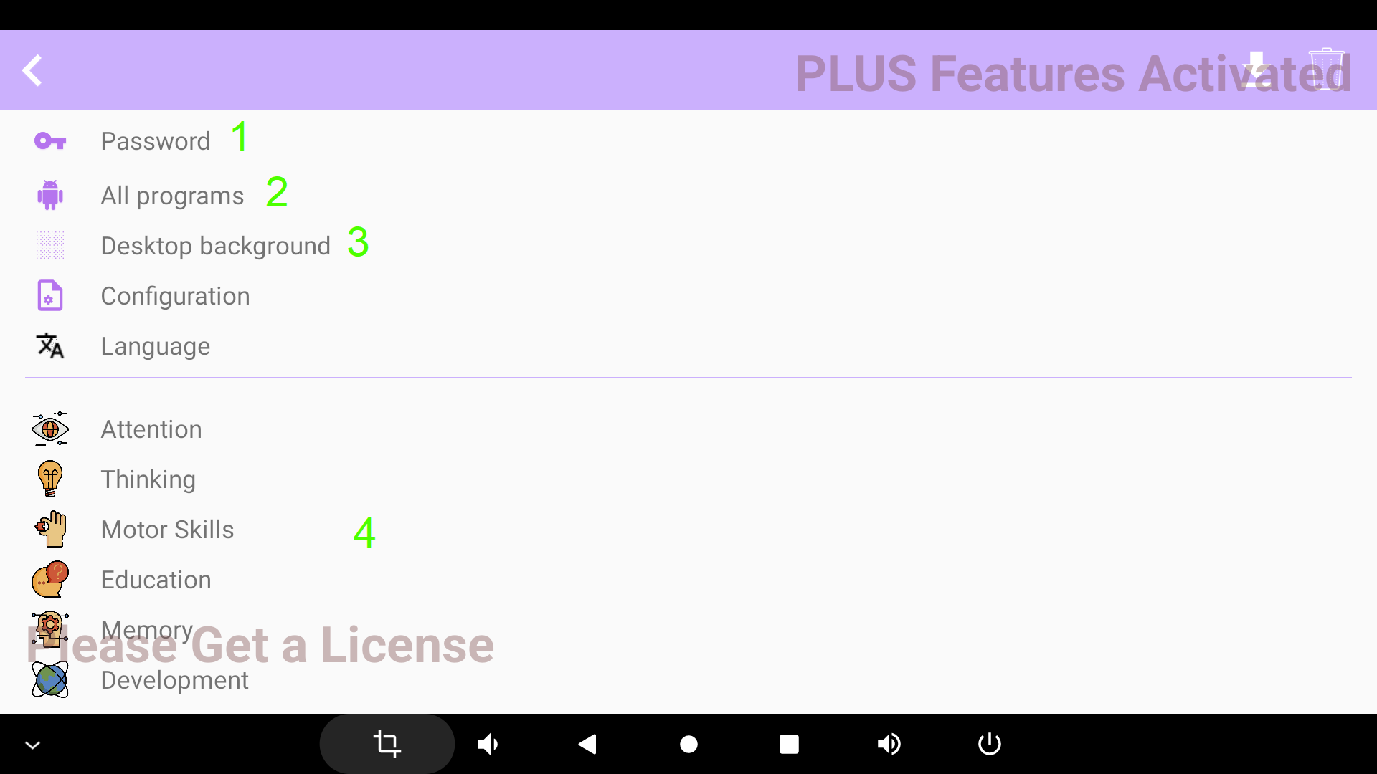

7.4 To change the password, click on the Password, after which a window for entering a new password will open. You need to tap the field again to bring up the cursor and input keyboard. After entering the new password, click the green check mark 2 on the right.

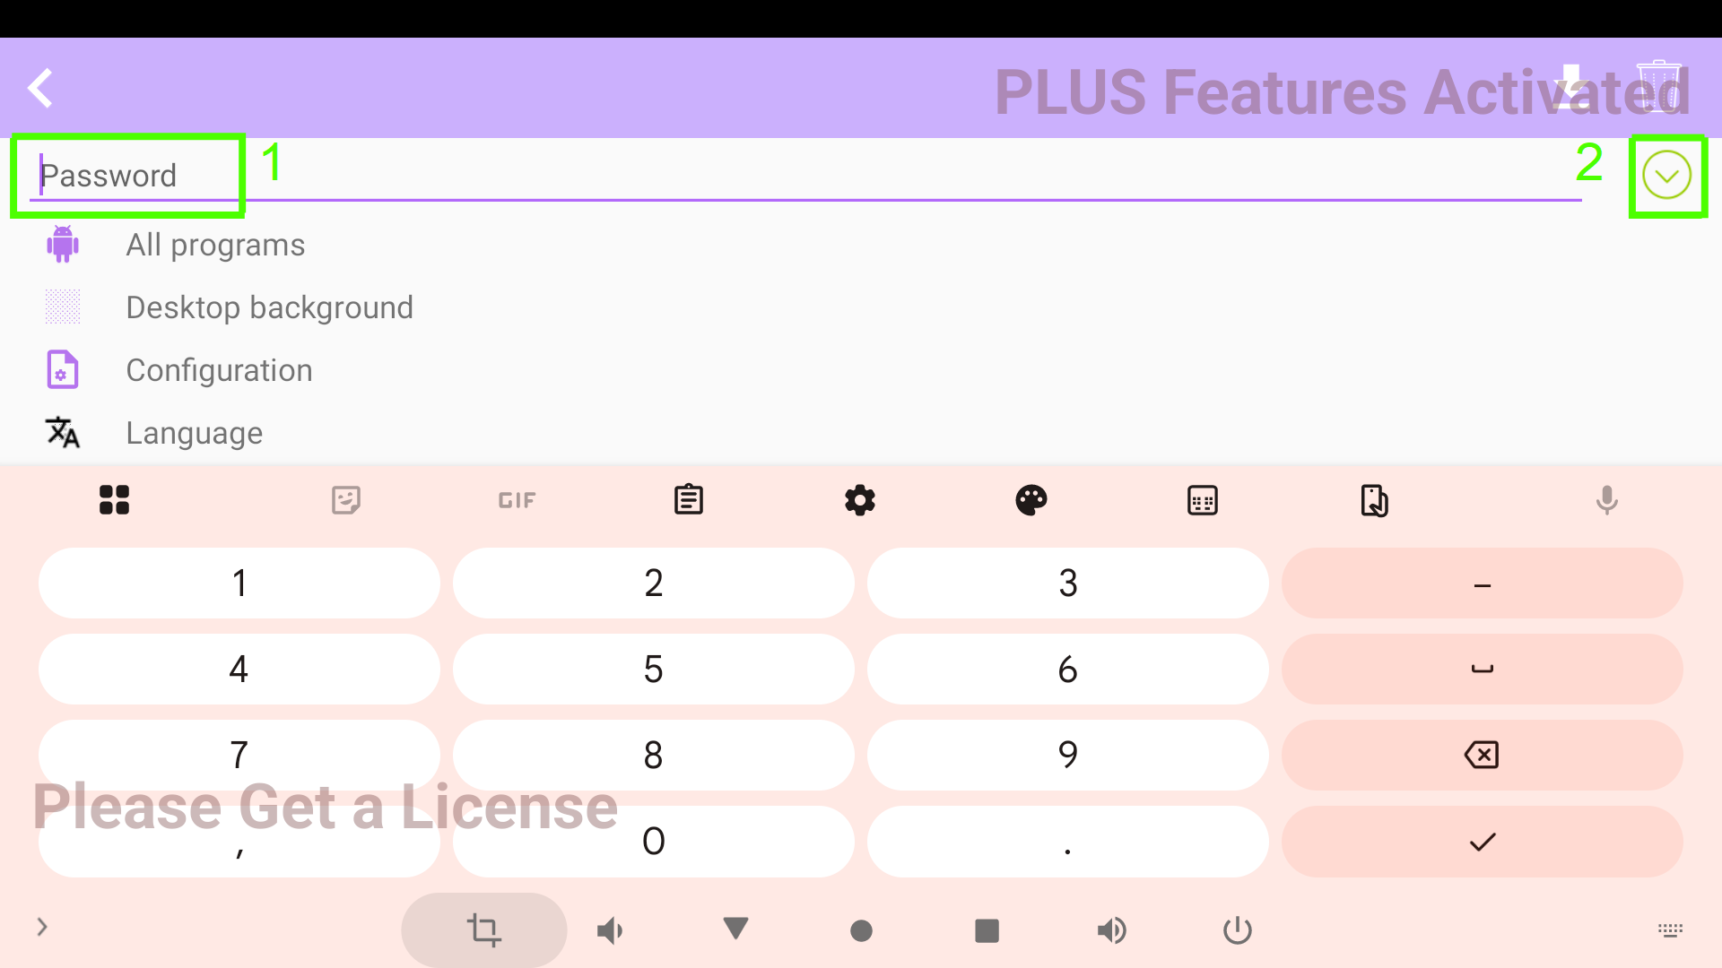
7.5 If you have installed your game applications and want to add them to a particular section, click All Applications, after which a window with the applications installed on the Interactive Table will open.

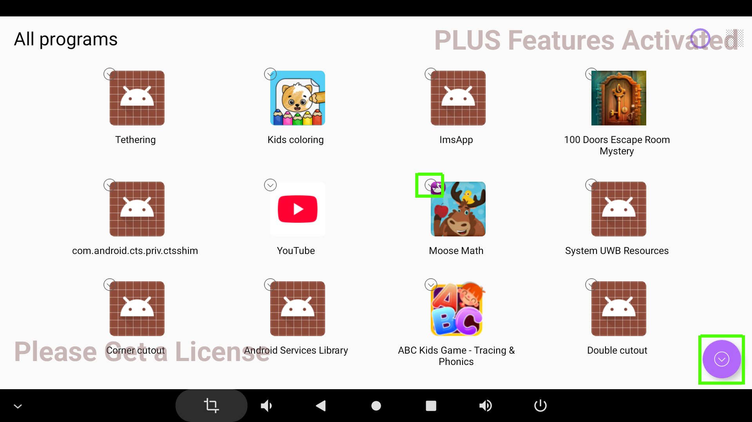
Click on the shortcut of any application and hold it down until a gray checkmark appears next to the shortcut. Next, find the application (or applications) you want to move to another section and click on its label again so that the check mark next to the label turns green (you can select multiple applications). Once selected, click the check mark in the lower right corner.
Next, enter the password set for INTBOARD JOY and click on the required section in the menu to which you want to add the selected application. A message should appear on the screen that The Application has Been Added.

7.6 To change the desktop background, click on Desktop Background, the following window will open:
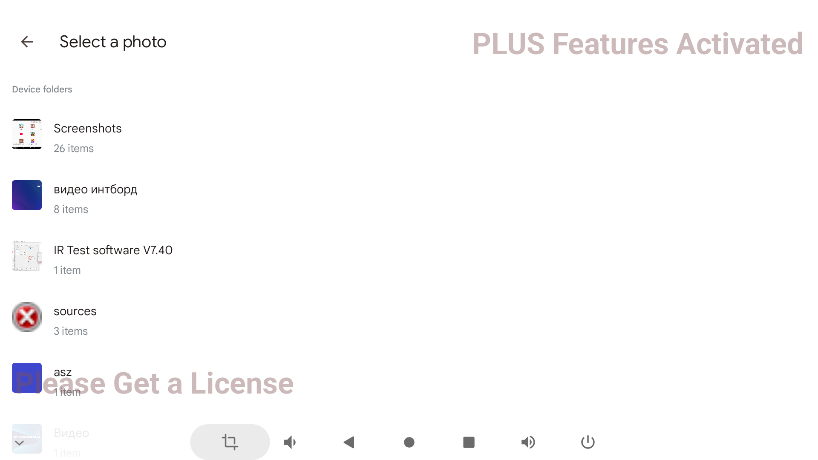
Select a new background in the Screenshots folder and confirm your choice.
NOTE! If you change the background, the default INTBOARD JOY app background will not be available for installation. It is recommended not to change the background of INTBOARD JOY.

7.7 Section Name.
To change the name of a section, click on one of the sections on the start page of the configuration. The following window will open:
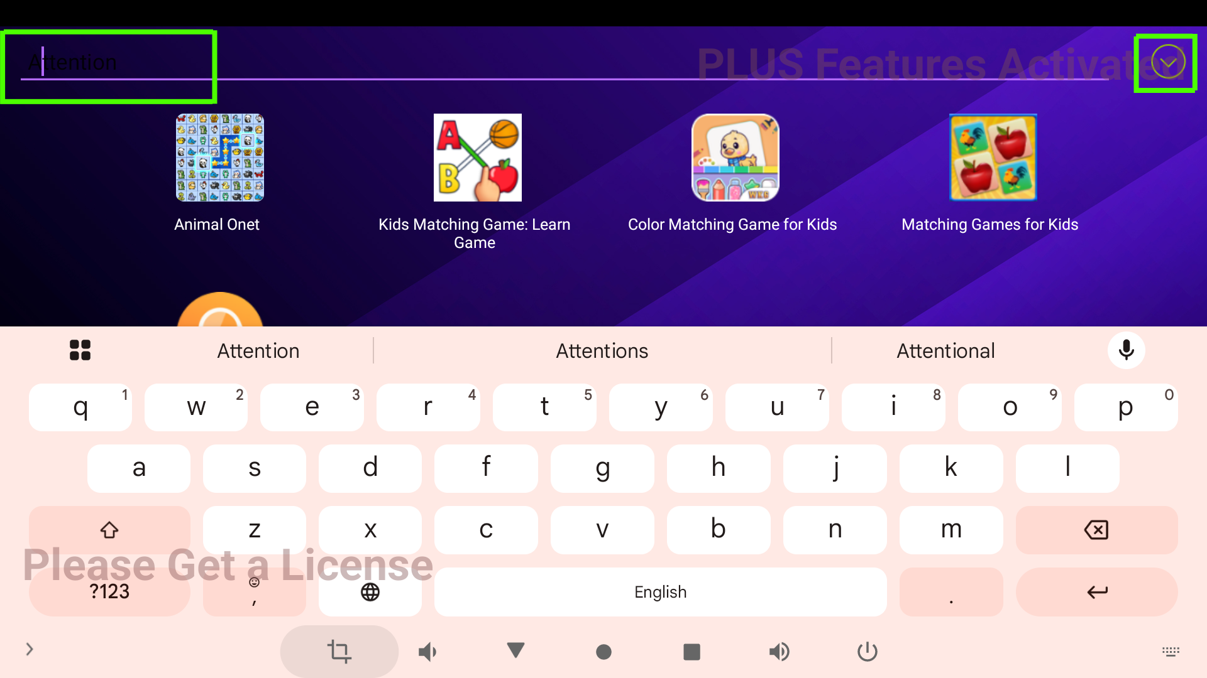
You need to click again next to the name to bring up the cursor and virtual keyboard. Use the keyboard to enter a new partition name and click the check mark in the right corner. The name of the section will be changed and displayed on the INTBOARD JOY setup interface start page.

8. MAINTENANCE

8.1. General maintenance of the Interactive Table by the owner includes removing dust and dirt from the surfaces.

8.2. Maintenance should be performed only when the power is turned off, and the power cable is disconnected from the power outlet.

8.3. Dust and dirt are removed with a soft cloth moistened with a special solution or special wet wipes.

8.4. To prevent moisture from getting inside the Interactive Table (which can lead to damage), do not wash it.

NOTE! Failure of the Interactive Table due to moisture or any other substance or object inside will not be considered a warranty case. All repair costs will be borne by the buyer, including delivery to the service center.

8.5 At least once every two years, the cooling system of the internal elements should be cleaned, and the thermal interfaces should be replaced. For this procedure, please contact the official service center, or a specialized service center.
NOTE! Cleaning of the cooling system and replacement of thermal interfaces are carried out on a paid basis
9. RULES OF TRANSPORTATION

9.1. Transportation of the Interactive Table is carried out by any type of covered freight transport with the use of the necessary environmental protection measures in accordance with the requirements of the current legislation, which has the required size of the cargo platform or body and carrying capacity.

9.2 The body of the vehicle must reliably protect the cargo from the effects of atmospheric precipitation. The Interactive Table must be transported in its original packaging with the possible addition of additional protective equipment provided by the carrier. Transport the Interactive Table in accordance with the transport markings on the packaging and securely.

NOTE! Damage to the Interactive Table as a result of its transportation by a vehicle that does not have the required size of the cargo platform or body and that does not protect it from the effects of atmospheric precipitation will not be considered a warranty case. All repair costs will be borne by the buyer, including delivery to the service center.

9.3 If the Interactive Table is transported by a carrier or courier service, the responsibility for the application of environmental measures, in accordance with the applicable law, lies with the respective carrier or courier service.

10. STORAGE

10.1 Long-term storage of the Interactive Table is possible in the original packaging at temperatures from 0ºС to +50ºС in a warehouse that is reliably protected from precipitation and without moisture condensation.

10.2 Short-term storage of the interactive table (up to 5 days) is possible in the original packaging at temperatures from -30ºС to +50ºС in a warehouse that is reliably protected from precipitation and without moisture condensation.

NOTE! Damage to the Interactive Table due to its storage in a room that does not meet the specified standards will not be considered a warranty case. The buyer will bear all costs of repairing the Interactive Table, including delivery to the service center.

11. ECOLOGY

11.1 Please do not dispose of the Interactive Table, its packaging, and its delivery kit as normal household waste.

11.2 Treat them as products that need to be processed accordingly.

11.3 If you need to dispose of them, take them to the appropriate collection points for recycling or in accordance with the regulations in your country.

NOTE! Dispose of the Interactive Table, its packaging, and delivery only in accordance with local regulations!

12. WARRANTY

12.1. Warranty is specified in the warranty card, which can be obtained by registering the product on the official website of the INTBOARD trademark.

12.2 The warranty card must be duly filled in, with the date of sale, serial number (if any) and the seller's stamp.

12.3 In the case of delivery by carrier, the buyer must keep the consignment note, which indicates the date of receipt. The warranty period will be calculated from the date of receipt of the product.

NOTE! If the buyer loses the consignment note, the warranty period starts from the date of sale specified in the warranty card.

12.4 In case of warranty repairs, the buyer shall contact the seller's service center at the address specified in the warranty card, by e-mail or by phone.

12.5 The product is accepted for service in the presence of a properly completed warranty card, a copy of the invoice (or check), in a complete set and in the original packaging, which must not be damaged.

NOTE! The seller may refuse the buyer warranty repairs in the event of:
- lack of original packaging;
- lack of a complete delivery package;
- absence of a copy of the expense invoice or check;
- absence of a completed warranty card;
- if the product or its parts have mechanical damage, chips, dents, or traces of self-repair;
- if there are traces of unauthorized repair or repair by third parties (not an authorized service center) on the product or its parts;
- malfunction of the product caused by malware;
- failure of the product as a result of the impact of natural disasters, catastrophes and acts of God;
- product failure in case of modification of the factory system software (firmware) by persons not authorized to perform such actions, including changing the parameters of the central processor (overclocking attempts) or other system parameters;
- damage to the Interactive Table that caused the destruction of microcircuits and/or burning of contacts, damage to ports for connecting peripheral equipment;
- damage to the Interactive Table caused by the customer's connection of external devices when the power is on, under the influence of static or electromagnetic fields;

The buyer will bear all costs of repairing the Interactive Table, including delivery to the service center.

In the event of damage to the packaging, service repairs are possible, provided that the damage is not a direct result of a breakdown.

13. TECHNICAL SPECIFICATIONS

Table 1. Technical Specifications of the Interactive Table INTBOARD STYLE version on Android*

 | STYLE 32 | STYLE 43
Supply voltage | ~230 V, 50 Hz
Maximum power consumption, W | 350 | 450
Case material | Metal
Display diagonal, inches | 32 | 43
Aspect ratio | 16:9
Resolution | 1920 х 1080
Screen surface, protection | Tempered glass
- Brightness, cd/m2 | 450
Contrast | 1500:1
Viewing angle, degrees | 178
Multitouch | 10 touches
Technology | Capacitive
Cursor speed | Up to 300 dots per second
Response time, ms | Up to 6
Type of backlight | LED
Matrix type | IPS
Matrix service life, hours | 60000
WiFi/Bluetooth | YES / YES
Speaker power, W | 6 (2 х 3)
CPU | MTK8788 (8 x 2 GHz)
GPU | Mali-G72 MP3
RAM, GB | 8
Memory, GB | 128
Operating system | Android 13.0
External connectors** | USB Type C – 1 pc, HDMI IN 2.0 – 1 pc, USB 3.0 – 1 pc, Mini jack 3.5 mm – 1 pc
Operating temperature, ºС | From 0 to +45, without moisture condensation
Storage temperature, ºС long-term | From 0 to +50, without moisture condensation
Storage temperature, ºС short-term | From -30 to +50, without moisture condensation
Table dimensions (LxWxH), mm | 119.5 x 61 x 62.5 | 144 x 61 x 77
Net weight, kg | 40 | 50
Product service life, years | 3
Package contents*** | Interactive table – 1 pc, power cable – 1 pc, Wi-Fi antenna – 1 pc, warranty card – 1 pc
Warranty period | Indicated in the warranty card

Table 2. Technical Specifications of the interactive table INTBOARD STYLE version on Windows*

 | STYLE 32 | STYLE 43
Supply voltage | ~230 V, 50 Hz
Maximum power consumption, W | 350 | 450
Case material | Metal
Display diagonal, inches | 32 | 43
Aspect ratio | 16:9
Resolution | 1920 х 1080
Screen surface, protection | Tempered glass
Brightness, cd/m2 | 450
Contrast | 1500:1
Viewing angle, degrees | 178
Multitouch | 10 touches
Technology | Capacitive
Cursor speed | Up to 300 dots per second
Response time, ms | Up to 6
Type of backlight | LED
Matrix type | IPS
Matrix service life, hours | 60000
WiFi/Bluetooth | YES / YES
Speaker power, W | 6 (2 х 3)
CPU | Intel Core i5-1130G7 or better
GPU | Intel Iris Xe Graphics (depending on the processor model)
RAM, GB | 8/16/32
Memory, GB | 128/256/512/1000
Operating system | Without an operating system
External connectors** | USB 2.0 - 2 pcs
Operating temperature, ºС | From 0 to +45, without moisture condensation
Storage temperature, ºС long-term | From 0 to +50, without moisture condensation
Storage temperature, ºС short-term | From -30 to +50, without moisture condensation
Table dimensions (LxWxH), mm | 119.5 x 61 x 62.5 | 144 x 61 x 77
Net weight, kg | 40 | 55
Product service life, years | 3
Package contents*** | Interactive table – 1 pc, power cable – 1 pc, Wi-Fi antenna – 1 pc, warranty card – 1 pc
Warranty period | Indicated in the warranty card

* Specifications may vary. The manufacturer may change the Technical Specifications without giving notice to the Buyer.
** Number and type of connectors may vary
*** Scope of delivery may differ from the one indicated. The manufacturer reserves the right to change the scope of delivery without giving notice to the Buyer;

Official representative in Poland: CREO SYNERGHY sp. z o. O
Address: ul. Marii Curie-Skłodowskiej 3/27 20-029 Lublin.
E-mail: info@intboard.pl
Company's website: intboard.pl

